**PRN212 Group Assignment**

**Building a Basic E-Commerce Management System with Windows Presentation Foundation (WPF)**

# 1. Introduction

In the world of e-commerce, timely handling of extensive data is essential to help customers in shopping with convenience and pleasure. Each e-commerce platform has a robust relational database at its center, efficient enough to store, fetch, and change information about products, customers, orders, and so on.

E-Commerce Website allows easy management of products, orders, customers, categories, payments information as well as cart management. Products are categorized in a user-friendly manner, as well as users can register and create multiple addresses in one account. Orders are placed by customers.

Payment methods are diversified which is aimed at enhancing security and flexibility in transactions. The shopping cart management system enables users to add, and check out products thereby helping with a smooth shopping process.

Imagine you're a developer of a FU Mini Tiki System named **FUMiniTikiSystem**. The application has a default account (admin account) whose email is “**admin@FUMiniTikiSystem.com**” and password is “**@@abc123@@**” that stored in the **appsettings.json**.

# 2. Assignment Objectives

In this assignment, you will:

* Use the Visual Studio.NET to create Windows Presentation Foundation (WPF) and Class Library (.dll) projects.
* Perform CRUD actions using Entity Framework Core.
* Use LINQ to query and sort data.
* Apply passing data in the WPF application.
* Apply 3-Layers architecture to develop the application.
* Add CRUD and searching actions to the application.
* Apply to validate data type for all fields.
* Run the project and test the WPF application actions.

# 3. Database Design

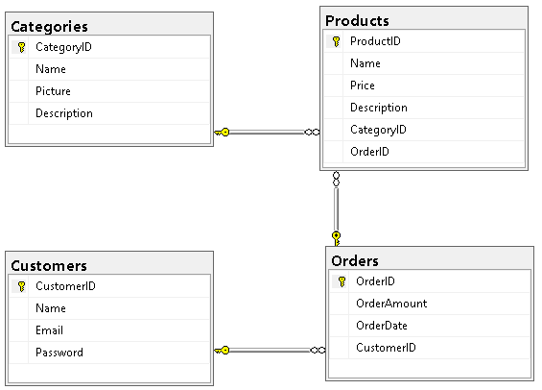

# 4. Main Functions

**User Authentication**:

Allow users to register and create accounts.

Provide features for user login, logout, and password management.

Store user information such as name, email, and password securely.

**Product Management**:

Display a catalog of products with details such as name, price, description, and images.

Allow users to browse products by category.

Implement search and filtering functionality for easy product discovery.

**Order Processing**:

Enable users to place orders securely.

Collect order details such as order ID, date, and total amount.

Provide order tracking functionality for users to monitor the status of their orders.

**Category Management**:

Allow administrators to create, update, and delete product categories.

Associate products with appropriate categories to facilitate navigation.

Display category images and descriptions to enhance user experience.

# 5. Note

* You must use **Visual Studio 2019 or above (.NET5/.NET6/.NET7/.NET8), MSSQL Server 2012 or above** for your development tools.
* To do your program, you must use **Windows Presentation Foundation. Note that** *you are not allow to connect direct to database from WPF, every database connection must be used through Repository and Data Access Objects. The database connection string must get from appsettings.json file.*
* Create Solution in Visual Studio named **StudentName_ClassCode_GASM.sln**. Inside your Solution, the Project WPF must be named: **StudentNameWPF.**
* Create your MS SQL database named **FUMiniTikiSystem** by running code in script **FUMiniTikiSystem.sql.**

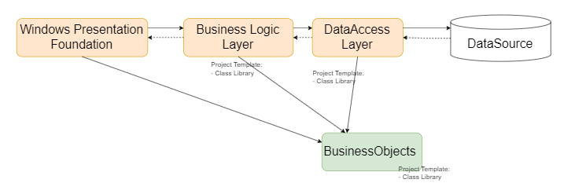

Data Source in this case is the SQL Server Database